Underestimation of the coexistence of iron deficiencies and thalassemia minors: a single institution experience in Taiwan
Chung-King Lin^{a,b}, Ling-Ping Chen^{a,c}, Hsiu-Lin Changª, Yung-Chuan Sung ^{a,c}
ª Division of Hematology-Oncology, Department of Internal Medicine, Cathay General Hospital, Taipei, Taiwan
^{b} Department of Internal Medicine, School of Medicine, College of Medicine, Taipei Medical University
^{c}Department of Internal Medicine, Medical College, Fujen Catholic University
林從慶^{1,2}陳苓萍^{1,3}張秀玲¹宋詠娟^{1,3}
- 台北國泰醫院內科部血液腫瘤科
- 台北醫學大學醫學系內科學科
- 私立輔仁大學醫學院內科系

Underestimation of the coexistence of iron deficiencies and thalassemia minors: a single institution experience in Taiwan
中文摘要

背景: 很多醫師忽略缺鐵性貧血與輕度海洋性貧血併存的可能性，而未能治療缺鐵血性貧血之必要，因此激發我們做此研究。
方法: 我們追朔檢閱病例，取樣自2007年8月1日至2012年12月31日止，曾在我們血液科實驗室有血色素電泳檢驗共3,892病例。我們由其全血球計數之特性、血色素電泳之結果及部分有分子生物學之檢驗而確定有輕度海洋性貧血之診斷;再檢視其血清有關鐵之檢驗及有無給鐵之治療及是否有效，而確定彼等是否併有缺鐵性貧血。
結果: 我們確定792例有輕度海洋性貧血，其中661例有鐵之檢驗。我們發現百分之31(202例)併有缺鐵性貧血。彼等有較低之血色素及紅血球計數。
結論: 在我們人口之輕度海洋性貧血並無鐵質過多的問題，相反的併發缺鐵性貧血並非罕見，應該有此認知而給予必要的治療。

Introduction
Iron overload is a common complication in thalassemia major and intermedia. It has been debated as to whether β-thalassemia minor has increased iron absorption. From our experience, we found that iron deficiencies commonly occur with thalassemia minors. Many non-hematologist physicians may neglect this coexistence and leave an iron deficiency untreated. Furthermore, physicians could miss hints of other potential underlying diagnoses, such as malignancies. This motivated us to conduct this study.
Patients and Methods
We retrieved all the records on those patients who had hemoglobin (Hb) electrophoreses done at our hospitals, a tertiary medical center in Taiwan. The time period was from August 1, 2007 to December 31, 2012, which resulted in a total of 3892 cases (Fig.1). We confirmed the diagnoses of thalassemia minors by complete blood count (CBC) indices (obtained from an auto-analyzer), Hb electrophoreses, and some with molecular tests. Then, we checked their iron studies, serum ferritin and /or serum iron (Fe) with total iron-biding capacity (TIBC), to diagnose the iron deficiency. We excluded those younger than two years of age (due to the possible effect of Hb F quantitation) and those without iron studies. All the diagnoses were confirmed by the hematologists.

Results
A total of 3892 cases were reviewed (Fig. 1). We identified 792 cases, of which 498 had α-thalassemia minor and 294 had β-thalassemia minor (307 males and 485 females; range 2 to 92 years; median 33 years). We excluded those below two years of age and those without iron studies, with total of 661 cases remaining. Thirty-one percent (31%, 202 cases) of the patients also had combined iron deficiencies (149 α-thalassemia minors and 53 β-thalassemia minors; 27 males and 175 females; range, 2-92 years; median, 34 years). Then, we excluded those with the potential for combined anemia of chronic diseases and borderline iron deficiencies, leaving for 457 cases for more meaningful data comparisons (Fig.1).
We found that the thalassemia minor patients who had co-occurrence of iron deficiencies had lower Hb (9.8 g/dL vs. 12.8 g /dL) and RBC counts (5.2 X 10⁶/µL vs. 6.0 X10⁶/µL), compared to those patients who did not have any iron deficiencies (Table1). The combined patients’ red cell distribution width - coefficient of variations (RDW-CV) were wider (18% vs. 16%). Using 11.5 g/dL as a cutoff point, the sensitivity was 79.8% and specificity was 82.6% (Fig. 2).

Conclusion
We did not see iron overload in thalassemia minor patients. On the contrary, we emphasize that the combination of an iron deficiency and a thalassemia minor is not uncommon especially in those patients who visited hospital clinics. We recommend that if Hb is below 11.5 g/dL in a case of thalassemia minor, the combination of IDA or other conditions should be evaluated. The possibility of the two conditions combined should be known, so physicians can recognize and treat it accordingly.

Table 1. Pure thalassemia (α and β) vs. thalassemia plus IDA
Parameter | Pure thal (n=259) |  |  | Thal plus IDA (n=198)
Parameter | Mean SD |  | Range | Mean | SD | Range | p value
Hb (g/dL) | 12.8 | 1.4 | 9.7-16.0 | 9.8 | 1.9 | 3.4-15.1 | <0.001
MCV (fL) | 65.1 | 4.6 | 48.7-78.7 | 62.1 | 6.7 | 47.1-78.8 | <0.001
RBC(10⁶/µL) | 6.0 | 0.6 | 4.0-9.0 | 5.2 | 0.7 | 3.2-6.5 | <0.001
RDW-CV (%) | 16.0 | 1.7 | 13.3-23.2 | 18.2 | 3.3 | 14.1-32.3 | <0.001
A2(%) | 3.6 | 1.7 | 1.0-8.3 | 2.8 | 1.3 | 1.0-6.5 | <0.001
Ferritin(ng/dL) | 205.5 | 129.5 | 30.5-760.0 | 22.3 | 42.8 | 0.6-362.0 | <0.001
Thal: Thalassemia, IDA: Iron deficiency anemia SD: standard deviation

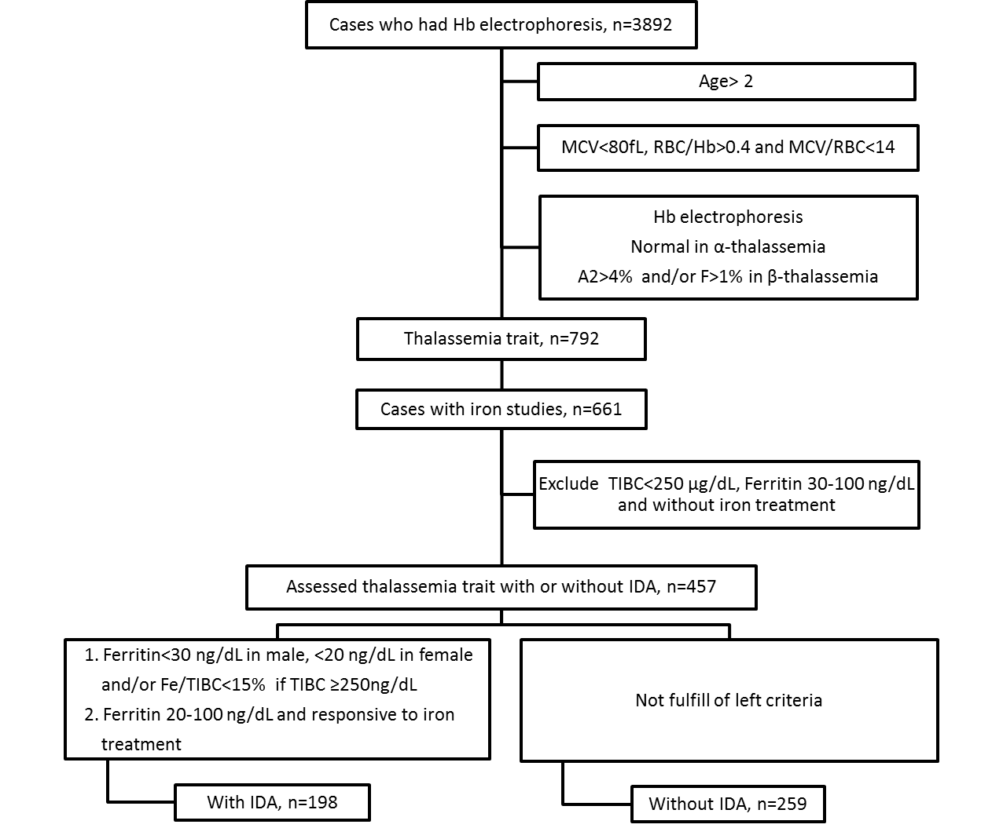
Fig.1. Working flowchart illustrating inclusion and exclusion criteria

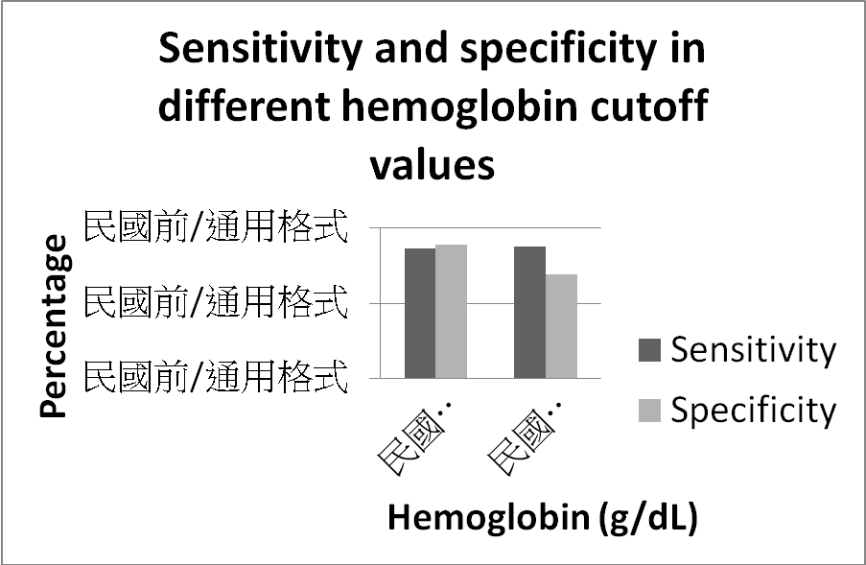
Fig.2. Sensitivity and specificity in different cutoff values of Hb (g/dL) to
detect the coexistence of iron deficiencies and thalassemia minors

