中文題目：右心室血栓併肺栓塞
英文題目：Right ventricle thrombus with acute pulmonary embolism
作 者：劉崢偉¹³，李任光¹，黃日新²，林恆旭¹
服務單位：亞東紀念醫院心臟血管中心 心臟內科¹ 心臟外科²
三軍總醫院松山分院內科部心臟內科³
Introduction：Pulmonary embolism (PE) may be asymptomatic and diagnosed by imaging procedures performed for other purposes. Mortality rate of acute PE ranged from about 60% to less than 1%.¹ Diagnostic work-up, risk stratification, and clinical management of acute PE were well established. However, specific treatment for patients with right heart thrombi(RHT) complicated acute PE were controversial. We reported a case presented with the incidental echocardiographic finding of right ventricle (RV) thrombi and reviewed literatures regarding PE and RHT.
Case report：The 62-year-old lady presented with a 5-day history of progressive dyspnea to the emergency department. She had medical history of hypertension and diabetes mellitus. On arrival, her heart rate was 82 beats per minute, respiratory rate 25 breath per minute, blood pressure 178/116 mm Hg, SpO2 91% on room air. Her jugular venous pressure had risen to 8cm. Auscultation revealed the high-pitched pansystolic murmur, grade III/VI in the lower left sternal border. Otherwise, the rest of her physical examination was unremarkable. A chest X-ray revealed cardiomegaly. An electrocardiography disclosed sinus rhythm. Artery blood gas showed pH 7.499, PaCO2 30.2mmhg, PaO2 53.6mmHg, HCO3 23.0, SaO2 90.9% while she was breathing ambient air. N-terminal-proBNP is 4,317 pg/ml. Troponin-I was within normal limit. A transthoracic electrocardiography performed in a modified parasternal long axis and apical four-chamber view, a “fava-bean-shaped” thrombus in the RV could be seen (Figure 1). Other echocardiograhpic findings included dilated right heart with RV hypokinesia, moderate tricuspid regurgitation, estimated RV systolic pressure 71 mm Hg, and left ventricle ejection fraction 62%. A computed tomography of chest showed multiple pulmonary embolus in bilateral pulmonary arteries extending into segmental branches (Figure 2). She received tissue plasminogen activator- alteplase therapy followed by concomitant enoxaparin and warfarin treatment. Due to respiratory distress, she must use bilevel positive airway pressure (BiPAP) ventilator. On the next day, she weaned off BiPAP ventilator and was discharged uneventfully a week later. Further investigation for tumor markers and deep vein thrombosis were negative.
Discussion：RHT, also known as emboli in transit, are originated from deep venous thrombi and the most of them are visualized in right atrium by echocardiography. With time, they migrate to RV. Finally almost all of them travel to the lungs, leading in PE. The approximate incidence of RHT in patients with acute PE is reported as 4% in a large prospective registry.² Presence of RHT is highly associated with RV dysfunction,^{2,3}. which is translated to poor short-term prognosis in patients with acute PE. ⁴ There is a 2.8-fold increased risk of death in those with presence of RHT within the first ten days but no difference in long-term mortality as compared with absence of RHT.³ Although there is no consensus about the optimal therapeutic options of RHT, heparin alone is associated with higher mortality rate. In accordance to the American Heart Association guideline, the present patient, who had submassive PE and severe RV strain, respiratory distress, and elevated N-terminal-proBNP, should receive alteplase if no contraindications to fibrinolysis are present.⁵ In general circumstance, RHT and RV dysfunction are improved expectedly by thrombolytic therapy within 12 hours. ⁶ Theoretically, surgical embolectomy with exploration of pulmonary arteries and right heart chambers during cardiopulmonary bypass is thought as the effective treatment. In fact, it is associated with increased risk of mortality as compare with thrombolytic therapy. ⁷ Mortality is as high as one-hundred percent when it is performed by inexperience cardiovascular surgeon.⁸ Therefore it should be preserved as alternative therapy for those with persistent or recurrent PE due to fragmentation of RHT and progressive hemodynamic instability after adequate medical treatment.
Conclusion：Detection of RHT may provide both diagnostic and therapeutic implications. On the basis of strong association between RHT, acute PE and RV dysfunction, Timely thrombolysis is emphasized in patients with confirmed RHT while awaiting a chest computed tomography. Surgical embolectomy should be preserved as second-line therapy in those with hemodynamic instability.

Reference
1. Giancarlo A, Cecilia B. Acute pulmonary embolism. N Engl J Med 2010;363:266-74.
2. Torbicki A, Galié N, Covezzoli A, Rossi E, De Rosa M, Goldhaber SZ. Right heart thrombi in pulmonary embolism. Results from the international cooperative pulmonary embolism registry. Journal of the American College of Cardiology. 2003;41(12):2245-51.
3. Mollazadeh R, Ali Ostovan M, Abdi Ardekani AR. Right cardiac thrombus in transit among patients with pulmonary thromboemboli. Clin Cardiol. 2009;32(6):E27-E31.
4. Grifoni S, Olivotto I, Cecchini P, Pieralli F, Camaiti A, Santoro G, et al. Short-Term Clinical Outcome of Patients With Acute Pulmonary Embolism, Normal Blood Pressure, and Echocardiographic Right Ventricular Dysfunction. Circulation. 2000; 101(24): 2817 -22.
5. Jaff MR, McMurtry MS, Archer SL, Cushman M, Goldenberg N, Goldhaber SZ, et al. Management of Massive and Submassive Pulmonary Embolism, Iliofemoral Deep Vein Thrombosis, and Chronic Thromboembolic Pulmonary Hypertension: A Scientific Statement From the American Heart Association. Circulation. 2011;123(16):1788-830.
6. Pierre-Justin G, Pierard LA. Management of mobile right heart thrombi: a prospective series. Int J Cardiol. 2005;99:381–388.
7. Rose PS, Punjabi NM, Pearse DB. TReatment of right heart thromboemboli. CHEST Journal. 2002;121(3):806-14.
8. Akilli H, Gul EE, Aribas A, Ozdemir K, Kayrak M, Erdogan HI. anagement of right heart thrombi associated with acute pulmonary embolism: a retrospective, single-center experience. Anadolu kardiyoloji dergisi : AKD = the Anatolian journal of cardiology. 2013. Epub 2013/07/10.

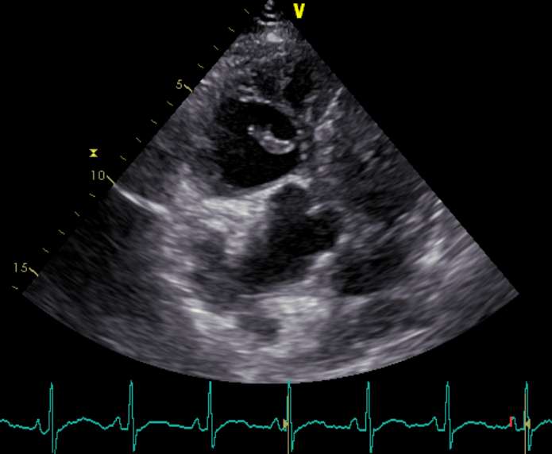
Ao
LA
LV
RV
Figure 1 A large shaggy thrombus (white arrow) was visualized directly in the RV. (Ao=aorta. LA=left atrium. LV=left ventricle. RV=right ventricle.)
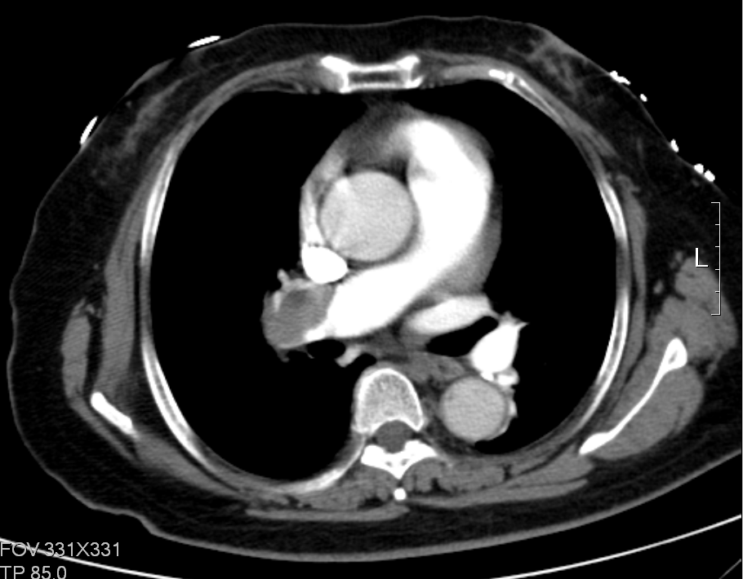
Figure 2 A large thrombus in the right pulmonary artery (white arrow).

