中文題目: 核梭狀桿菌血症併局限性心包膜蓄膿初期表現酷似廣泛前壁心肌梗
塞 : 一個罕見的病例報告
英文題目: Fusobacterium Nucleatum Bacteremia Associated with Loculated Pericardial Empyema Mimicking Extensive Anterior Wall Myocardial Infarction : a rare case report
作 者: 蔡錦焜¹ , 林至展², 許哲翰³, 吳慧中⁴ , 吳整昌¹ , 鄧世綸¹
服務單位: 澄清綜合醫院中港分院 ¹內科部重症醫學科 , ²內科部心臟內科,
³內科部感染科, ⁴心臟血管外科

Introduction :
Fusobacteria nucleatum bacteremia is uncommon and has been associated with a variety of clinical presentations. We describe a patient who presented with Fusobacterium nucleatum bacteremia with an unusual septic location of loculated pericardial empyema with syncope as the initial symptom

Case Report:
A 71-year-old previously healthy female presented to our emergency department by emergency medical services after a witnessed syncopal event . She had noted unresponsive in the post office , someone called 119.
On arrival in the emergency department, the patient was confused , her breathing appeared shallow and labored. The temperature was 41.4°C, the blood pressure 132/105mm Hg, the pulse 113 beats per minute, and the respiratory rate 25 breaths per minute. Oxygen saturation was 85 percent while the patient was receiving 100 percent oxygen through a mask . On physical examination , The pupils were 3 mm in diameter, equal, round and reactive to light. There was no crepitus in the soft tissue of the neck, no cervical lymphadenopathy, and her neck was supple. An examination of the chest, heart, and abdomen disclosed no abnormalities . Because of respiratory distress , endotracheal intubation with mechanical support was performed . An electrocardiogram showed ST elevation in precordial Leads , V1-V6 ( Fig 1 ) . Extensive anterior wall myocardial infarction was highly suspected . She underwent cardiac catheterization. The results of coronary angiography were normal . Owing to shock with acute respiratory failure , she was admitted to MICU for management of shock.
After admission to MICU , her temperature was 39.1°C; heart rate was 132 beats/min; respiratory rate 24 breaths/min; and blood pressure was 73/38 mm Hg. she was treated with ceftriaxone 2 g every 24 hours after pan-culture. She continued to receive aggressive fluid resuscitation and inotropic support . A right internal jugular central venous catheter was placed emergently for the administration of her vasoactive infusion and hemodynamic monitoring. She regained consciousness after approximately two hours later. A transthoracic echocardiogram revealed mild hypokinesis of distal IVS and apex with LV EF 50% , no intracardiac vegetations, or intracardiac thrombus . Abdominal Echo revealed liver cysts , no abscess.
The next day , Contrast enhanced CT of chest and abdomen showed loculated right pericardial effusion about 3.5 x 6 cm in size abutting RA , suspicious of empyema ( Fig 2 ) . Surgical procedures including exploratory pericardiotomy with a pericardial window and two chest tubes were performed , turbid abscess in pericardial abscess and inflammation change of pericardium were noted.
On the 4th day after admission , Gram-negative rods began growing on her blood culture and were reported as probable Fusobacterium. Metronidazole 500mg q6h was added . Her fever resolved and her hemodynamic improved
On the 7th day , Pericardial fluid anaerobic culture and blood culture yielded Fusobacterium nucleatum . Her antibiotics were changed to ampicillin-sulbactam
On the 9th day . Contrast enhanced CT of neck was performed to search for primary source . Neck CT suspected small filling defects within the left retromandibular vein, with suspicious surrounding fat stranding , jugular thrombophlebitis with thrombus should be considered ( Fig 3 ) . Extubation was performed on the 9th day after admission . The remainder of her hospital course was uneventful . She received 28 days of antibiotics . She then was discharged to home. .
Discussion :
Fusobacteria are anaerobic , non-spore-forming Gram negative bacilli forming part of the family Bacteroidaceae. They have been isolated frequently from a wide variety of clinically significant anaerobic infections, including oral and dental infections, brain abscesses, empyema, hepatic and intra-abdominal abscesses, septicaemia and endocarditis, as well as soft-tissue infections . Two Fusobacterium species, F. nucleatum and F. necrophorum, are the most commonly isolated pathogens within this genus . Fusobacterium bacteremia had a significant morbidity and mortality in humans, and accounted for less than 1% of all bacteremias in adults and 10% of anaerobic bacteremias . Fusobacterium bacteremia should prompt a search for primary source in oropharynx or a dental infection and accompanying septic thrombophlebitis of internal jugular vein .
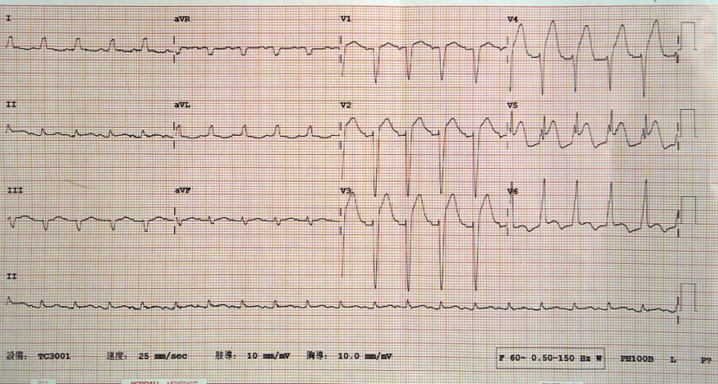
Fig. 1 : Electrocardiography showed ST elevation in V1-V6

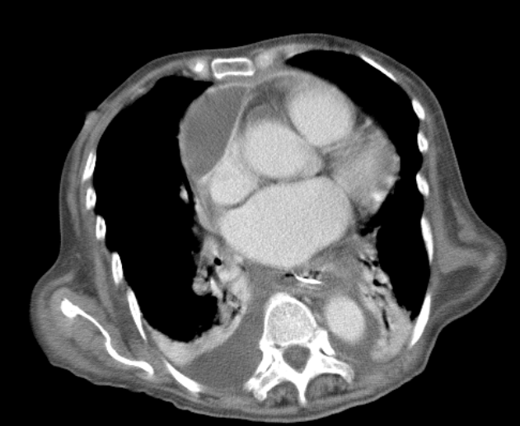
Fig. 2 : Contrast enhanced CT of chest showed loculated right pericardial
effusion and bilateral pleural effusion

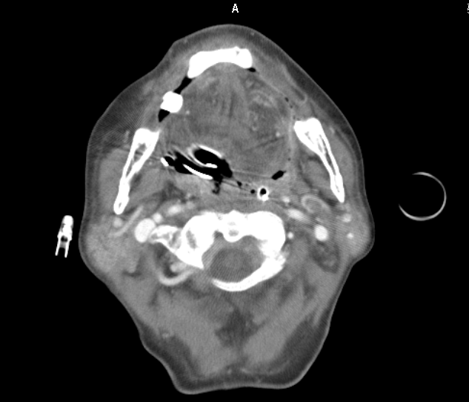
Fig. 3 : Contrast enhanced neck CT suspected small filling defects within the left retromandibular vein.

