中文題目：一個合併有甲狀腺風暴及糖尿病酮酸血症之預後不佳之Takotsubo 心肌病變個案---一個稀有的個案報告
英文題目：A case of Takotsubo cardiomyopathy precipitated by thyroid storm and diabetic ketoacidosis with poor prognosis – A rare case report
作 者：吳韋璁¹ 黃虹綾¹,許栢超^{2,3}
服務單位：高雄醫學大學附設中和紀念醫院¹內科部心臟血管內科, ²高雄醫學大學醫學院醫學系內科

Introduction
Takotsubo cardiomyopathy (TCMP) is also named as stress cardiomyopathy, broken-heart syndrome, or apical ballooning syndrome, which is a form of reversible, transient systolic dysfunction over the left ventricle [1-2]. Generally, TCMP can be triggered by physical or emotional stress [3]. Both of thyroid storm and diabetic ketoacidosis (DKA) were rare causes of TCMP [4-11]. Herein, we reported a rare case of TCMP precipitated by thyroid storm and DKA simultaneously and finally leaded to catastrophic clinical outcome
Case report
An 81-year-old female was a case of type-2 diabetes mellitus (DM), hypertension and old cerebral vascular accident. This time, she suffered from palpitation, chest tightness, and abdominal fullness in combination with vomiting and diarrhea, and was brought to our emergency department (ED) for help. Anxiety and excessive sweating were also noted in recent three months.
On arrival at our ED, vital signs were pulse rate 146 beats/min, respiratory rate 22/ min, blood pressure 110/60 mmHg, and body temperature 38.5 C. Electrocardiogram (ECG) revealed sinus tachycardia with ST elevation over V2-V4 (Figure 1A). Chest X-ray (CXR) showed cardiomegaly and pulmonary congestion (Figure 2A). Because ST elevation myocardial infarction was highly suspected, emergent coronary angiography was performed but showed nearly normal finding. In addition, echocardiography revealed impaired left ventricular systolic function (Ejection fraction: 35.4%) with apical hypokinesia to akinesia, which was compatible with apical ballooning sign of TCMP (Figure 1B). Due to impending respiratory failure caused by decompensate heart failure, the patient was then intubated under mechanical ventilator support.
Initial laboratory data revealed white blood cell count: 17100/μL, C-reactive protein: 24 mg/L, creatinine: 2.14 mg/dL, blood sugar: 566 mg/dL, blood osmolarity: 339 mOsm/kg, blood ketone 2.2 mmol/L, and elevated cardiac biomarkers (CK-MB: 17.5 ng/mL; troponin 8.75 ng/mL). Arterial blood gas showed high anion gap metabolic acidosis (PH: 7.16, HCO₃: 8.3 mmol/L) and urinalysis revealed glucosuria and strongly positive of urine acetone. Under the impression of DKA, insulin and fluid replacement were given according to the monitor of central venous pressure. However, despite of gradual correction of hyperglycemia and metabolic acidosis, patient’s conscious level became disturbance in combination with persistent hyperthermia, dyspnea, and anuria. We further checked the thyroid function and the data revealed elevated of T4 level (6.14 ng/dl) but thyroid stimulating hormone (TSH) was below the detectable limit (<0.03 uU/mL). Thyroperoxidase antibodies, thyroglobulin antibodies, and anti-microsomal antibodies were negative, while TSH antibodies was positive. Thyroid storm was highly suspected via the Burch-Wartofsky-Score (60/140) [12], and also satisfied with the thyroid storm diagnostic criteria of the Japan Thyroid Association. Therefore, the patient received intravenous hydrocortisone, oral propylthiouracil, potassium iodide and propranolol for treatment of thyroid storm. Propranolol was later discontinued because of unstable hemodynamic. The patient was then transferred to our intensive care unit (ICU) for further care.
During ICU stay, we performed continuous veno-venous hemofiltration (CVVH) for anuria, metabolic acidosis and unstable hemodynamic. Vasopressor was given for shock status and empirical antibiotic with ceftriaxone was also given for possible infection control. After 4 days of treatment, hemodynamic of the patient became more stable and we successfully weaned off vasopressor and CVVH. Follow-up echocardiography revealed improvement of apical ballooning sign and ejection fraction. Laboratory data also revealed decreased free T4 level (2.8 ng/dl) and correction of metabolic acidosis. However, the patient’s consciousness still deteriorated by time but computed tomography of brain did not reveal remarkable finding. Furthermore, CXR rapidly progress to bilateral diffuse infiltration and patch (Figure 2B), and arterial blood gas revealed progression of hypoxemia (PaO₂/FiO₂ ratio < 200 mmHg) even under titrating up the setting of mechanical ventilator. Under the impression of acute respiratory distress syndrome (ARDS), we adjusted the ventilator setting to low tidal volume and high positive end-expiratory pressure. However, desaturation was still noted even under FiO₂ 100% supply. The patient finally expired on the 8th days after admission.

Conclusions:
This is the first case of TCMP precipitated by thyroid storm and DKA simultaneously and finally leaded to poor prognosis.
This rare case reminds us that despite TCMP being a transient cardiomyopathy with good prognosis, physicians should survey the possible underlying disease cautiously to avoid undesired and catastrophic clinical outcome.

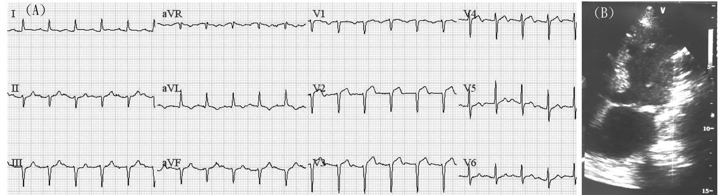
Figure 1
Electrocardiogram (ECG) revealed sinus tachycardia with ST elevation over V2-V4 (Figure 1A, left panel).
Echocardiography revealed impaired left ventricular systolic function with apical hypokinesia to akinesia, which was compatible with apical ballooning sign of TCMP (Figure 1B, right panel).

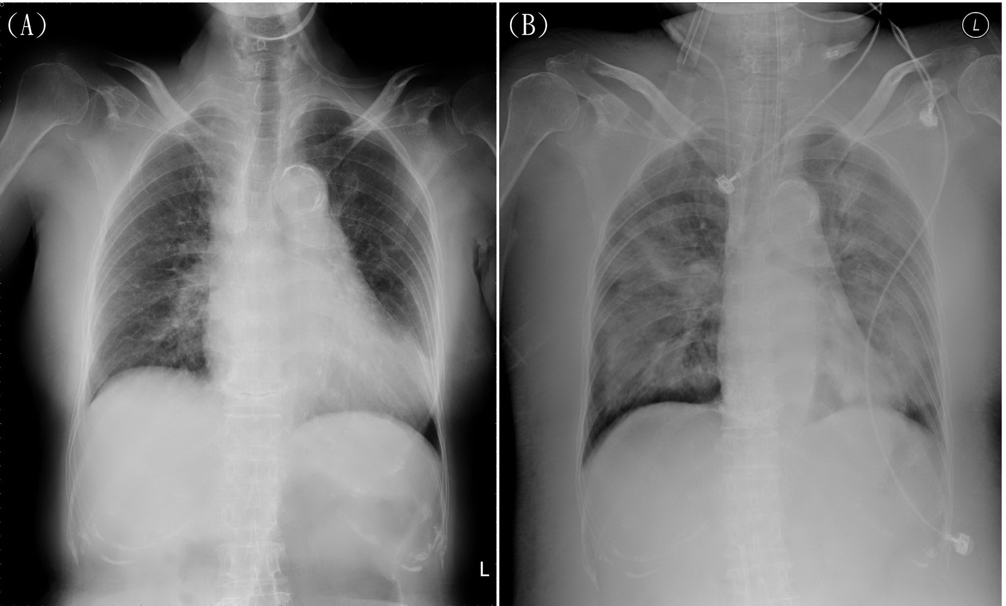
Figure 2
Initial Chest X-ray (CXR) showed cardiomegaly and pulmonary congestion (Figure 2A, left panel)
CXR rapidly progress to bilateral diffuse infiltration and patch after recovery of heart function, which is compatible with the diagnosis of adult respiratory distress syndrome (Figure 2B, right panel).

Reference :
- Gianni M, Dentali F, Grandi AM, Sumner G, Hiralal R, Lonn E: Apical ballooning syndrome or takotsubo cardiomyopathy: a systematic review. European Heart Journal 2006, 27:1523-1529.
- Prasad A, Lerman A, Rihal CS. Apical ballooning syndrome (Tako-Tsubo or stress cardiomyopathy): a mimic of acute myocardial infarction. Am Heart J 2008; 155(3): 408-17.
- Sharkey SW, Lesser JR, Zenovich AG, Maron MS, Lindberg J, Longe TF, et al. Acute and reversible cardiomyopathy provoked by stress in women from the United States. Circulation 2005; 111(4): 472-9.
- Eliades M, El-Maouche D, Choudhary C, Zinsmeister B, Burman KD: Takotsubo cardiomyopathy associated with thyrotoxicosis: A case report and review of the literature. Thyroid 2013.
- Rossor AM, Pearce SH, Adams PC. Left ventricular apical ballooning (takotsubo cardiomyopathy) in thyrotoxicosis. Thyroid. 2007 Feb;17(2):181-2.
- Alidjan F, Ezzhati M, Bruggeling W, van Guldener C. Takotsubo cardiomyopathy precipitated by thyrotoxicosis. Thyroid. 2010 Dec;20(12):1427-8.
- Hutchings DC, Adlam D, Ferreira V, Karamitsos TD, Channon KM. Takotsubo cardiomyopathy in association with endogenous and exogenous thyrotoxicosis. QJM. 2011 May;104(5):433-5.
- Kohut AR, Jain D. Perfusion and wall motion abnormalities in a patient with diabetic ketoacidosis. J Nucl Cardiol. 2009 Mar-Apr;16(2):316-20.
- Lin CH, Chen CC, Tsai MK, et al. Ampulla cardiomyopathy in a patient with diabetic ketoacidosis: A case report. J Intern Med Taiwan 2007;18:120-4.
- Katayama Y, Hifumi T, Inoue J, Koido Y. A case of Takotsubo cardiomyopathy induced by accidental hypothermia and diabetic ketoacidosis. BMJ Case Rep. 2013 Apr 3;2013.
- Nanda S, Longo S, Bhatt SP, Pamula J, Sharma SG, Dale TH. Stress cardiomyopathy - a unique presentation of diabetic ketoacidosis. Ann Clin Biochem. 2009 May;46(Pt 3):257-60.
- Burch HB, Wartofsky L: Life-threatening thyrotoxicosis. Thyroid storm. Endocrinology and metabolism clinics of North America 1993, 22:263.

