中文題目：ㄧ個影像學型態似黏液瘤的感染性左心房血栓的稀有個案報告
英文題目：An Infected Left Atrial Thrombus Mimicking a Myxoma
作 者：黃虹綾¹ ,吳韋璁¹,許超群^{2,3}
服務單位：¹高雄醫學大學附設中和紀念醫院內科部,²胸腔內科, ³高雄醫學大學醫學院醫學系
Introduction
A intracardiac infectious thrombus was rare, most of the cases are usually reported in the ventricular chamber and frequently associated with the complication of myocardial infarction. Only five cases of left atrial infectious thrombus was reported. Transthoracic echocardiography (TTE) is used to detect intracardiac mass but Transesophageal echography(TEE) had better resolution for defining the characteristics of masses. Surgery can provide the exact diagnosis, which is very important to further treatment and prognosis.
Regarding the intracardiac infectious thrombi , the most common microorganisms are Gram-negative bacilli and Staphylococcus aureus .
Herein, we came across an extremely rare case of intra-cardiac infectious thrombus, diagnosed based on surgical intervention.

Case presentation
A 76-year-old woman with a medical history of thyroid cancer, chronic kidney disease, congestive heart failure, and atrial fibrillation was admitted to our intensive care unit for bradycardia and hypotension due to digoxin overdose. She had intermittent fever and malaise for one month and took over-the-counter antipyretics, which might be the cause of rapid deterioration of renal function and subsequent digoxin overdose. Laboratory studies revealed leukocytosis, elevated C-reactive protein, and pyruia. Levofloxacin (500mg every 48 hours) was administered for suspected urinary tract infection. Transthoracic echocardiography accidentally found a huge, floating, pedunculated mass attached to the posterior wall of left atrium (Fig 1), which was not seen in the echocardiography performed 6 months ago. The mass is echogenic with a hypoechoic center. Computed tomography angiography showed a pine cone-like pedunculated tumor (4.4 cm) in left atrium, with both enhancing and low attenuation components (Fig 2). Although image findings suggested a myxoma with possible central necrosis, rapid development of the mass made the diagnosis of a huge thrombus more possible. On the next day, she underwent mass removal surgery. The mass was 5 cm x 3.2 cm, soft, and well-defined, with a small stalk attached to left atrial dome. Incision of the excised mass yielded frank pus. The histopathological examination proved a huge thrombus with abscess formation. Special stains for microorganisms, however, were all negative. The patient developed profound septic shock and died four days after the operation. Infected left atrial thrombus is rare and may present with subtle clinical symptoms. Without early diagnosis and proper management, the prognosis is usually dismal.
Conclusion :
This case reminds us that we should keep infectious thrombus in mind for the differential diagnosis of intracardiac mass, especially in those immunocompromised patients. Even the clinical symptoms are subtle and obscure, history taking carefully could help a lot. Atypical pathogens and fungal infection should be taken into consideration, except for the blood and pus culture, molecular assay (PCR) and immunofluorence examination might be the necessary tool for further diagnosis. No standard treatment was proposed before due to the rare entity and the high mortality rate ,surgery may be the choice of treatment with antibiotics, but the complication of the surgery should also be taken into consideration.

Fig.1 legend: A huge, floating, pedunculated mass attached to the posterior wall of left atrium was found under transthoracic echocardiography
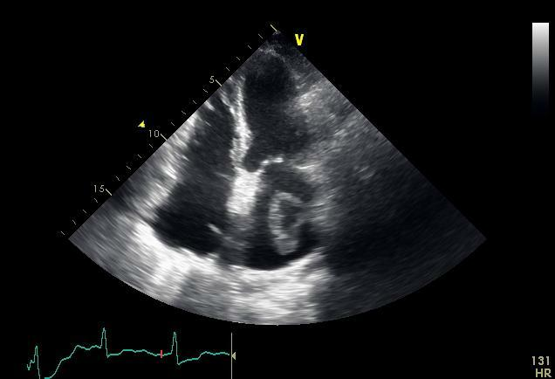
Fig 2 legend : Computed tomography angiography showed a pine cone-like pedunculated tumor (4.4 cm) in left atrium, with both enhancing and low attenuation components (Fig 2).

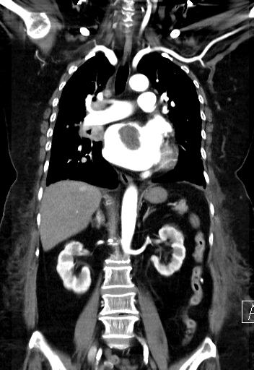

Reference :
1. Kakkavas A, Fosteris M, Stougiannos P, Paschalis A, Damelou A, Trikas A: A giant, free-floating mass in the left atrium in a patient with atrial fibrillation. Hellenic journal of cardiology: HJC= Hellēnikē kardiologikē epitheōrēsē, 52:462.
2. Dhawan S, Tak T: Left atrial mass: Thrombus mimicking myxoma. Echocardiography 2004, 21:621-623.
3. Fernández-Ruiz M, López-Medrano F, Alonso-Navas F, Aguado JM: Coxiella burnetii infection of left atrial thrombus mimicking an atrial myxoma. International Journal of Infectious Diseases 2010, 14:e319-e321.
4. Okayama H, Kawasaki S, Takagaki Y, Kawada H, Sumimoto T, Hirayama T: Infection of Left Atrial Thrombus Associated With Mitral Stenosis*. Chest 2000, 117:1201-1203.
5. Dedeilias P, Roussakis A, Koletsis EN, Zervakis D, Hountis P, Prokakis C, Balaka C, Bolos K: Left atrial giant thrombus infected by Escherichia Coli. Case report. Journal of cardiothoracic surgery 2008, 3:18.
6. Divchev D, Podewski EK, Mengel M, Meyer GP, Drexler H, Schaefer A: Inflammatory, abscess-forming foreign body reaction mimics a thrombus formation on an atrial septal defect closure device: A commented case report. European Journal of Echocardiography 2007, 8:298-302.
7. Yunus M, Saikia M, Lyndoh N, Thabah R, Bardoloi J, Day S, Selvam C: Successful removal of a very large left atrial organized infected thrombus (weight 200 gram) and Mitral valve replacement: A case report. The Internet Journal of Thoracic and Cardiovascular Surgery 2010, 14.
8. Peters PJ, Reinhardt S: The echocardiographic evaluation of intracardiac masses: a review. Journal of the American Society of Echocardiography 2006, 19:230-240.
9. Shapiro LM: Cardiac tumours: diagnosis and management. Heart 2001, 85:218-222.
10. Lamas C, Eykyn S: Blood culture negative endocarditis: analysis of 63 cases presenting over 25 years. Heart 2003, 89:258-262.

