中文題目：肝癌以脊椎轉移為最初的臨床表現之個案報告

英文題目 : Hepatocellular carcinoma with spinal metastasis as its initial clinical presentation--A case report

作 者：蔡元榮, 莊岳泉

服務單位：屏東基督教醫院
Abstract
This 77-year-old man patient presented to ward via emergency room with the chief complaint of lower back pain for a 3 months. The pain was dull in nature, about 4/10 of pain scale that localized at lower back pain (more prominent over right side) with radiation to his abdomen. Associated symptoms consisted of progressive bilateral lower leg weakness and numbness had occurred 5 days prior to his hospitalization . His mobility had been affected since then. Besides of neurological symptoms mentioned, he also suffered from incontinence with urinary retention.
Magnetic resonance intensity exam of Lumbar spine showed the lobulated soft tissue tumor about 12x9x8 cm in the right paravertebral region of T10 to T12 with extension to epidural region with compression of central cord which was suggestive of multiple bony metastasis of T9 to T12( Figure 1 and Figure 2 ). His sonography of abdomen revealed a heterogeneous, irregular tumor about 3.8x4.1cm in size at right lobe (S6-S7)(Figure 3). His AFP level was extremely high[AFP: >58344 ng/mL, (normal range: 0-8 ng/ml)]. Pathology of the soft tissue taken from his back uncovered a picture of metastatic hepatocellular carcinoma(HCC), composed of sheets of moderately differentiated neoplastic cells, with hyperchromatic nuclei and abundant cytoplasm. Immunostaining were positive for HSA, AFP,CD34 and GPC-3.
This patient was diagnosed of hepatocellular carcinoma with thoracic spinal metastasis (T9-12) complicated with paraplegia (T1NxM1 , stage IVB) based on his clinical presentation and series imaging and laboratory workup.
Even though Taiwan is a regarded as a hyper-endemic area of HCC, according to a retrospective study conducted in Taiwan in a period of 13 years [1], 46 patients were shown to have HCC and Central nervous system (CNS) metastasis, but there was only 10 had spinal metastasis [1]. This suggests that it is very rare to have distant metastasis to spinal cord with hepatocellular carcinoma as primary origin.
Literally reviewing of cases that have been reported, there has been no case with spinal metastasis with primary HCC that are without any risk factors. Kleinschmidt DeMaster reported 2 cases of US native with cirrhosis and HCC that developed epidural space metastasis [2]. 2 cases with acute spinal cord compression as part of the clinical manifestations in patients with spinal metastasis from hepatocellular carcinoma were reported by I-Hung Hseuh[3] and Nobuya Sano[4] respectively. In both cases, patients were previously diagnosed of hepatitis B with liver cirrhosis and chronic hepatitis C respectively. Cases shown above were none like our case that was free of any risk factors of HCC.
In conclusion, we should always bear in mind the diagnosis of distant metastasis of HCC when patient with no predisposing factors of HCC presented to us with acute spinal cord syndrome in an area that is hyper-endemic.

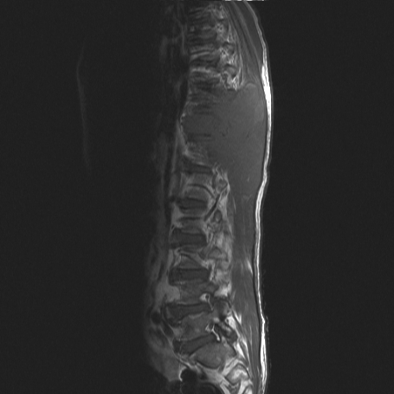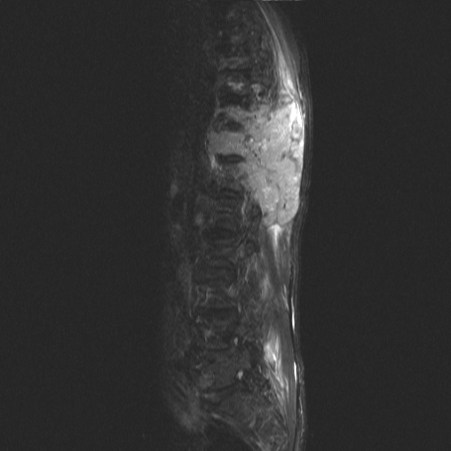
Figure 1. T1(Left) and T2(right) images of MRI of L-spine in sagittal view showing
a 12x9x8 cm mass in the right paravertebral region of T10 to T12

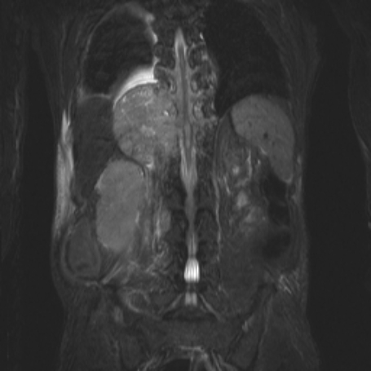
Figure 2 T2 image of MRI of L-spine in coronal view showing a lump measuring 12*9*8cm in right paravertebral region of T10 to T12.

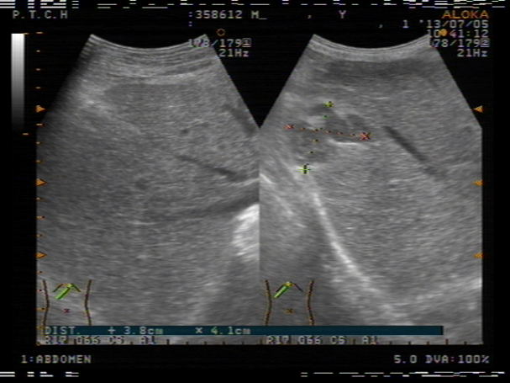
Figure 3. A.3.8-4.1 mass heterogenous lesion over S6-S7 in abdominal echography.

References
1.
Central nervous system involvement in hepatocellular carcinoma: clinical characteristics and comparison of intracranial and spinal metastatic groups.
Hsiao SY, Chen SF, Chang CC, Lin CH, Chang WN, Lu CH, Chuang YC, Tsai NW.
J Clin Neurosci. 2011 Mar;18(3):364-8.

2.
Hepatocellular carcinoma metastases to the epidural space.
Somerset H, Witt JP, Kleinschmidt-Demasters BK.
Arch Pathol Lab Med. 2009 Dec;133(12):1975-80

3.
A patient with spinal metastasis from hepatocellular carcinoma discovered from neurological findings.
Tamaki K, Shimizu I, Urata M, Kohno N, Fukuno H, Ito S, Sano N.
World J Gastroenterol. 2007 May 21;13(19):2758-60.

4.
Hepatocellular Carcinoma with Acute Spinal Cord Compression
as the Initial Presentation
Helen L. Po, Pei-Hao Chen, Sho-Jen Cheng1, and I-Hung Hseuh
Acta Neurol Taiwan 2003;12:191-195.

