中文題目：肺炎克雷白氏菌引起之原發性腰肌膿瘍：病例報告
英文題目：Primary psoas muscle abscess caused by Klebsiella pneumoniae: a case report
作 者：劉博堃¹，陳志銘²，吳再坤³
服務單位：童綜合醫療社團法人童綜合醫院 內科部¹ 感染科² 腎臟科³
Introduction: A psoas muscle abscess is a collection of pus in the iliopsoas muscle compartment. It may arise via contiguous spread from adjacent structures (secondary abscess) or by the hematogenous route from a distant site (primary abscess). A secondary psoas muscle abscess may be monomicrobial or polymicrobial and frequently consist of enteric organisms (both aerobic and anaerobic bacteria). Primary psoas muscle abscesses are most frequently due to infection with a single organism and the most common causing bacteria is Staphylococcus aureus. Primary psoas muscle abscess caused by Klebsiella pneumoniae is rare. We herein reported a case of primary psoas muscle abscess caused by K. pneumoniae.
Case Report: A 69-year-old woman was brought to our emergency room (ER) by her family because of consciousness disturbance. The patient has the history of diabetes mellitus for about 6 years, and had regular follow-up at the local medical department. She denied other systemic diseases and any allergic history. Patient’s consciousness recovered to normal (Glasgow coma scale was 15) and her blood sugar level was 331 mg/dL on arrival to the ER. The patient said that she had fatigue and poor appetite for about 1 week. There was no fever, chills, or symptoms of common cold during the course. The findings of physical examination revealed a mild grade fever (up to 37.5 ℃) accompanied with mild right back soreness. Laboratory testing revealed a peripheral-blood leukocyte count of 15100 cells per cubic millimeter, with 88% polymorphonuclear cells and the level of C-reactive protein was 23.2 mg/dl. The remainder of complete blood count and the comprehensive metabolic panel were within normal limits. Urinalysis revealed pyuria (WBC 5-10 cells per high-power field). The tentative diagnosis on admission was urinary tract infection and she began receiving intravenous injections of cefazolin 1 g every 8 hours. Because of persistent high-grade fever (up to 39 ℃) after admission, abdominal ultrasound was performed on the third hospitalization day and showed a lobulated, elongated and hypoechoic lesion (13 cm in length) at the right retroperitoneal region (Fig. 1). Then computed tomography (CT) of the abdomen with the administration of contrast material was performed and indicated the right psoas muscle abscess with right perirenal space involvement (Fig. 2). The patient’s clinical condition improved obviously after CT guide percutaneous catheter drainage of psoas muscle abscess and intravenous injection of ceftriaxone 2 g once daily. Two sets of blood cultures and one set of pus culture yielded K. pneumoniae which was susceptible to all tested antimicrobial agents. Patient was uneventfully discharged with Cravit (oral form) antibiotic on 17 hospitalization days.
Discussion: Klebsiella pneumoniae is an important pathogen of patients with diabetes in Taiwan. The most common primary disease caused by K. pneumoniae is liver abscess. Primary psoas muscle abscess caused by K. pneumoniae is rarely reported. However, a deadly case of K. pneumoniae related fulminant psoas muscle abscess had ever been reported. Flank pain (91%) and fever (70%) are the most common presenting symptoms of psoas muscle abscess. In our case, the patient had no typical signs and symptoms of psoas muscle abscess(only fever and mild right back soreness without knocking pain), and the psoas muscle abscess was incidentally found by abdominal ultrasound. By this case report, we suggest that diabetic patients with febrile diseases should receive abdominal imaging studies to early diagnosis of an abscess. In addition, K. pneumoniae can also be the causing pathogen of psoas muscle abscess, especially in diabetic patients.
Fig 1: Abdominal ultrasound revealed a lobulated, elongated and hypoechoic lesion, measuring l3 cm in size, at the right retroperitoneal region,
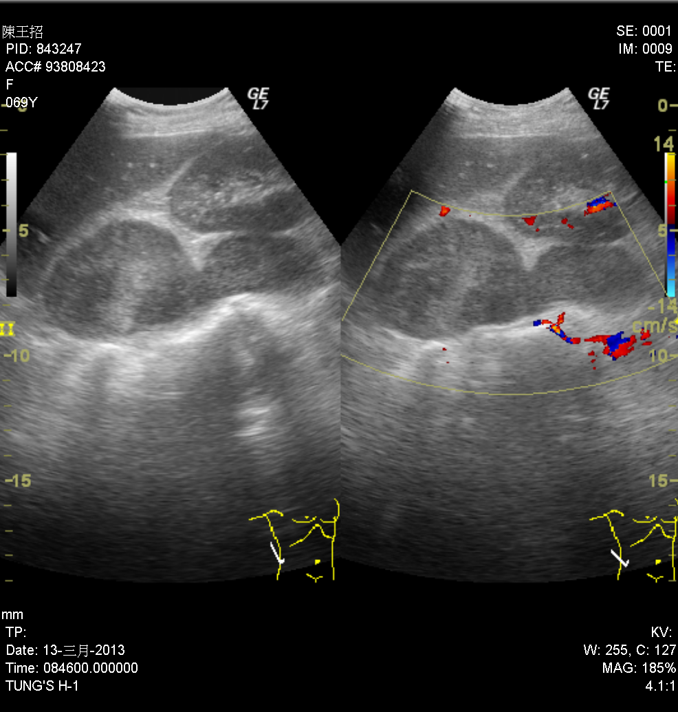

Fig 2: The computed tomography of the abdomen showed a right psoas muscle abscess with right perirenal space involvement.
