中文題目：一位原因不明之腎臟周邊出血的病人出現 Cullen and Grey Turner signs
英文題目：Cullen and Grey Turner signs in idiopathic perirenal hemorrhage
作 者：鍾焜明，孫啟書，莊世松
服務單位：奇美醫院一般內科

A 47-year-old man presented to the emergency department with a 24-hour history of sudden-onset left-flank pain. There was no history of trauma, and he was not taking anticoagulants. There was no family history of bleeding diathesis or hematologic disease. On physical examination, he had ecchymosis around his umbilicus and on his left flank(Cullen and Grey Turner signs, respectively)(Fig.1). Abdominal computed tomography(CT) showed a massive hematoma around the left kidney suggestive of bleeding from a renal tumor. The patient received conservative treatment, and the bruising gradually resolved in a month. Follow-up abdominal CT showed substantial resolution of the left perirenal hematoma, with no evidence of neoplasm.
Cullen and Grey Turner signs indicate internal hemorrhage and warrant careful history-taking and investigations, including coagulation studies, serum lipase and amylase, and imaging. Cullen sign, first described in 1918, is superficial bruising in the subcutaneous fat around the umbilicus(1). It has been described in acute pancreatitis, rectus sheath hematoma, splenic rupture, perforated ulcer, intra-abdominal cancer, and ruptured ectopic pregnancy, and as a complication of anticoagulation(2). Grey Turner sign refers to ecchymosis of the flanks and may occur in conjunction with Cullen sign, especially in patients with retroperitoneal hemorrhage(3). When Cullen or Grey Turner signs result from acute pancreatitis, they signal severe disease, with a mortality estimate as high as 37%(3).
In our patient, Grey Turner sign was likely caused by hemorrhage spreading from the anterior perirenal space to the posterior renal fascia and subsequently to the lateral edge of the quadratus lumborum muscle. The blood likely diffused via the falciform ligament to the subcutaneous tissue around his umbilicus, resulting in Cullen sign. Renal neoplasm is the most common cause of spontaneous perirenal hemorrhage, but roughly 30% of instances are related to other disease entities including polyarteritis nodosa, infection, cyst rupture, nephrosclerosis and preeclampsia(4). No cause for the hemorrhage can be identified in about 7% of instances(4). Abdominal CT should be considered in the workup of Cullen and Grey Turner signs; it has a higher sensitivity and specificity than ultrasonography for identifying renal pathology(4).

Fig.1 (A)periumbirical ecchymosis(Cullen sign) and (B) connecting patches of ecchymosis on the left flank(Grey Turner sign) in a 47-year-old man with sudden onset of left-flank pain.
A
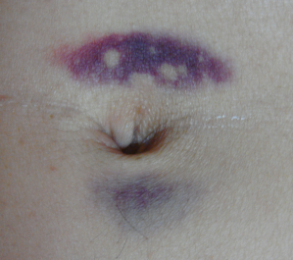
B
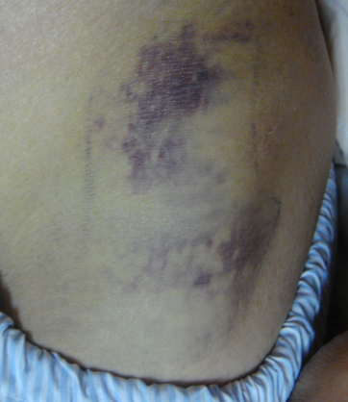

References
- Cullen TS. A new sign in ruptured extrauterine pregnancy. Am J Obstet Gynecol 1918;78;457
- Harris S, Naina HVK. Cullen’s and Turner’s signs. Am J Med 2008;121;682-3
- Mookadam F. Cikes M. Cullen’s and Turner’s signs N Engl J Med 2005;353:1386
- Zhang JQ, Fielding JR, Zou KH. Etiology of spontaneous perirenal hemorrhage: a meta-analysis. J Urol 2002;167:1593-6

